**LAB IN PSYCH**

**LAB REPORT 4 TUTORIAL 4**

**Sequence Learning Experiment**

**DIYA BAROT AU2120073**

**INTRODUCTION**

In the domain of psychology and behaviour, in particular, the notions of learning and contingency are connected. Contingency is the relationship between two occurrences in which the occurrence of one depends on or has an impact on the outcome of the other. Contrarily, learning is the process through which people pick up new skills or ways of behaving as a result of their experiences and interactions with their environment. Because learning frequently entails identifying and comprehending the dependent links between environmental events or stimuli, learning and contingency are closely connected concepts. People who have learned are better equipped to modify their behaviour and forecast outcomes based on the occurrences they have seen and experienced. The relationship between events and their effects is crucial to learning, whether it be through operant conditioning, classical conditioning, or more advanced methods. In the experiment, participants are trained to recognize and anticipate specific patterns or sequences, evaluating their ability to acquire and retain sequential information to understand learning processes.

**PURPOSE**

We performed this experiment in the class on psychopy to investigate how individuals acquire, retain, and generalize sequential information, shedding light on cognitive processes involved in skill development and memory consolidation.

**METHOD**

We were given a video tutorial recorded by our professor to refer to while performing this experiment. First step was to add fixation followed by adding lines which had almost similar properties. The following method is what I used:

1. Open PsychoPy, two routines, but both are mostly identical

2. Add Fixation: Choose the Polygon option, rename the polygon as ‘Fixation’, Start = ‘0’

Stop duration = ‘1.0’, Shape of fixation = ‘cross’ the layout option and set the size (w,h)

= (10,10); the position will be (0,0) because we need the polygon displayed on the center

of the screen, fill colour and border color = Grey or copy paste -0.2549, 0.2392, 0.2549

Click OK

3. Add polygon: Insert a polygon, name = line1 (to avoid confusion), start = 1.0, stop ‘null’

(keep it empty), Shape = rectangle, size [w, h] = (100,10), Position [x,y] = (-

150,0), spatial units = pix, orientation = 90.

4. Add more polygons: (in total there will be four polygons named respectively line1, line

2, line 3, and line 4) The values for 2,3,4 will be same except for the

position [x, y] for line2 = (-50,0)

position [x, y] for line3 = (50,0)

position [x, y] for line4 = (150,0)

5. Add probe: With polygon component, name = probe, start = 2.0, stop = null, Shape =

Triangle, In layout tab size [w, h] = (10,10), position [x, y] = (pos,60) with ‘set every

repeat, spatial units = pix, Click OK

6. Add key response: Name = key_resp, start = 2.0, Stop = null, Allowed keys = ‘null’

with constant, in data tab ; correct answer = $corr_resp, click ok

After this I added loop in the first routine with the loopType “sequential” and another loop in the second routine with the loopType “fullRandom”.

Later, I checked the values and ran the experiment.

**RESULTS**

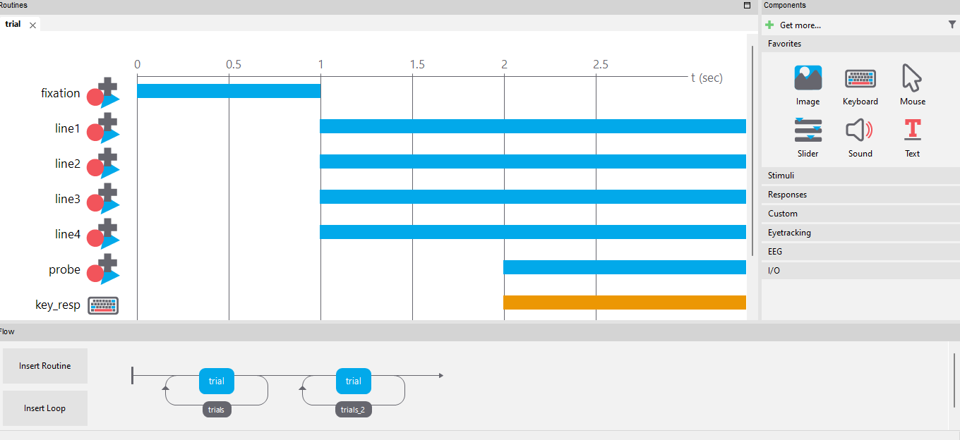

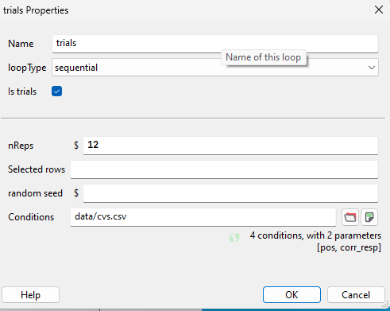

**DISCUSSION**

* The reaction time between the two tasks of sequential and random can be explained through the cognitive processes involved. In sequential tasks, there is a sense of familiarity with the material. As a result of the sequence's predictability, the work can become more comfortable with the user, which helps speed up processing. There is also a certain expectation involved with sequential learning which makes it easy to predict the upcoming stimuli and reduce cognitive load. All of this collectively results into shorter RT.
* The longer RT in random is explanatory as the exact opposite of what happens in sequential happens here. The participant has no idea of the stimulus which makes the processing slower and increases the cognitive load.

Counterbalancing the order of sequential and random can influence a lot. It can enhance the validity of the results. This technique reduces or minimises the order effects. It can increase one’s statistical powers by mitigating expectations and increase generalizability. It can reduce the practice effect which makes the results more valid.

**LINK TO GUTHUB**

[**https://github.com/diyabarotAU2120073/DIYABAROT/upload/main**](https://github.com/diyabarotAU2120073/DIYABAROT/upload/main)